1Vegetarian appetizers
- Samosa: 2pieces (V)-3.99
Golden crisp triangles filled with mildly spiced potatoes and peas.
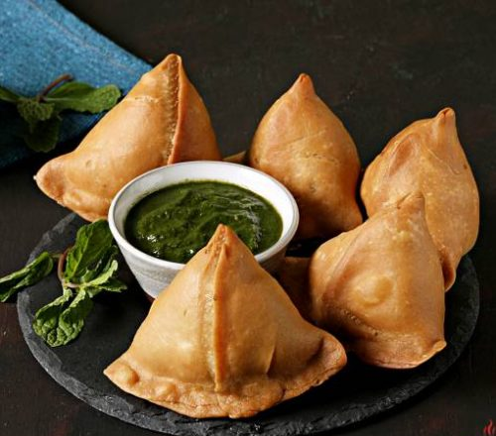
- Vegetable pakora: 5pcs (V GF)- 3.99
Mildly spiced assorted vegetable fritters.

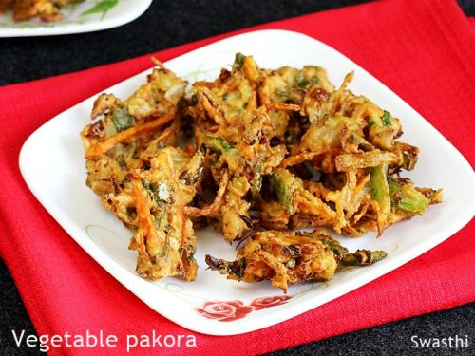
- Paneer pakora: 4pcs (GF)-7.99
Home-made delicately spiced cheese fritters.

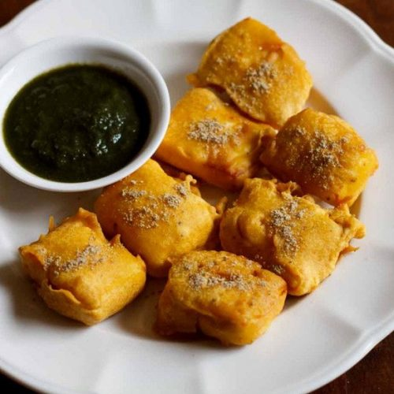
- Mirchi pakora V (GF)-6.99
Hot Peppers fritters

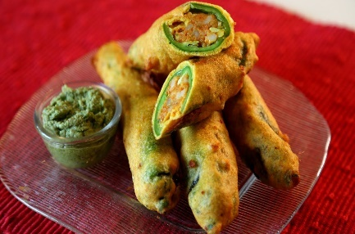
- Spinach and Kale Pakora V(GF)-7.99
Fresh Spinach and Kale crispy Fritters
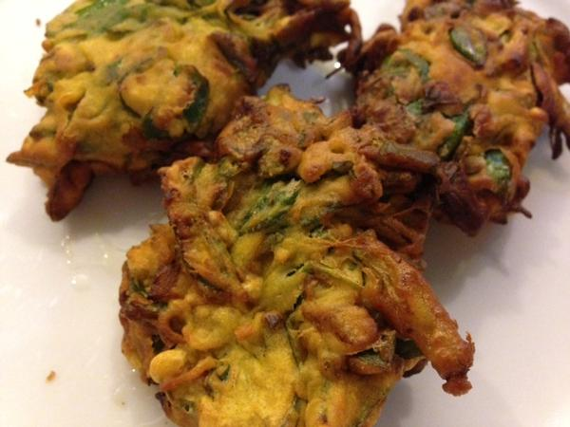
- Aloo bhonda: 2pcs (V)-5.99
Mildly spiced potato balls coated with chickpea flour

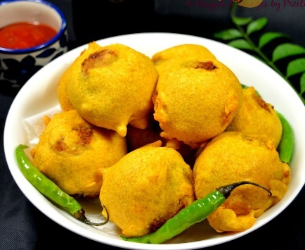
- Aloo tikki: 2 pcs (V)-5.99
Home-made patties made with potatoes and peas.

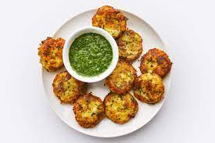
- Paneer cutlet: 2pcs (GF)-7.99
Cottage cheese cutlet mildly spiced.

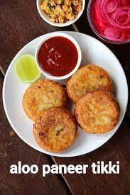
- Vegetable cutlet: 2pcs (V)-7.99
Vegetable patties mixed with healthy and delicious Oats.

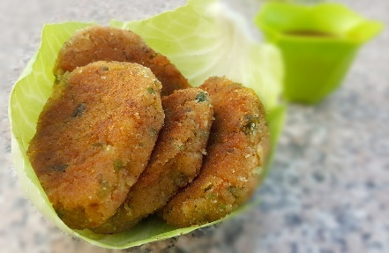
- Spring roll :4 pcs (V )-5.99
Spring rolls filled with cabbage and vegetables.

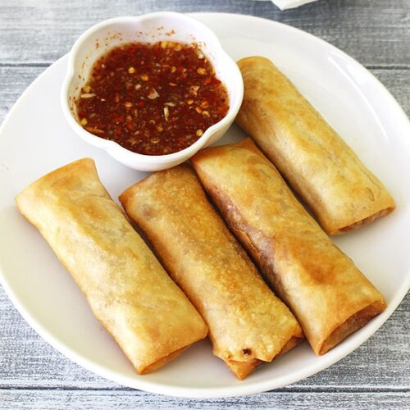
- Kachori: 2 pieces (V)-Stuffed pastry with mildly spiced moong dal

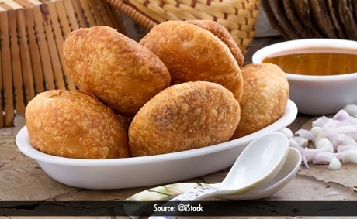
- Paani puri (V)-6.99
Wheat puffs served with chickpea salad and spicy Mint water.

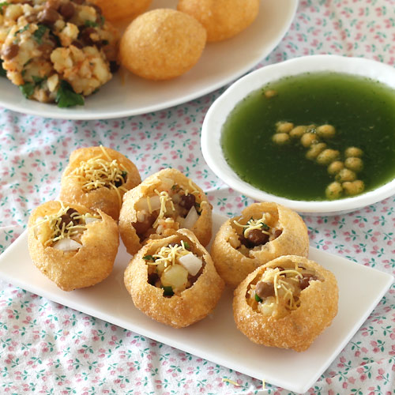
- Assorted vegetable platter (V)-9.99
Samosa, vegetable pakora, Mirchi pakora, Paneer pakora and Aloo tikki

Chaat corner
- Samosa chaat (V)-7.99
2 pcs pf samosa crumbled and topped with chick peas, yogurt, mint and tamarind sauce.

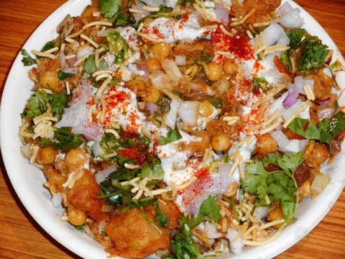
- Quinoa chaat (V GF)-7.99
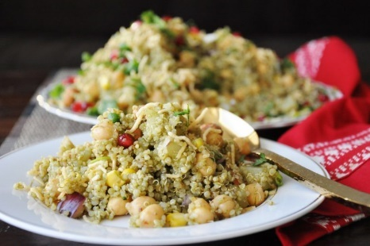
- Aloo tikki chaat (V GF)-7.99
Home made patties made with potatoes and peas tossed with mint and tamarind chutney.

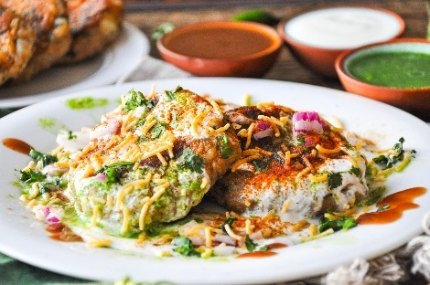
- Dahi vada chaat (GF)-7.99
Donut shaped lentil balls topped with potatoes, fresh home-made yogurt, tamarind and mint sauce.

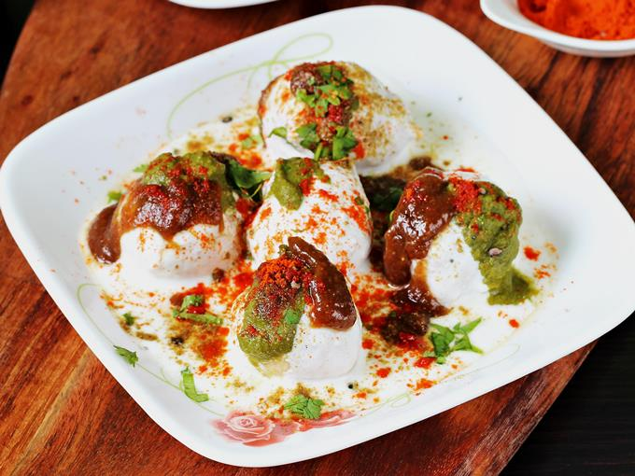
- Bombay Bhel puri (V GF)-7.99
A Bombay favorites! A mixture of assorted crisps and noodles tossed with onion, potatoes, tomatoes and chutneys.

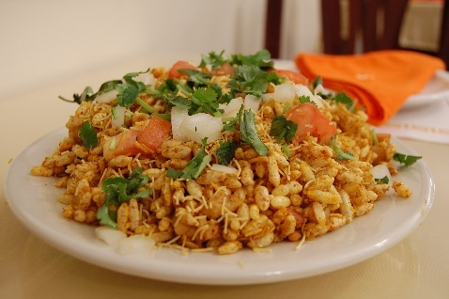
- Channa chaat (V GF)-7.99
Chickpeas mixed with potatoes, cucumbers, onion and condiments.

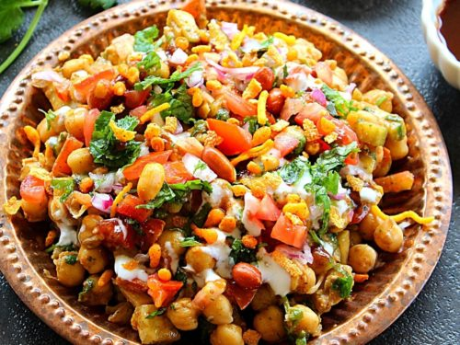
- Aloo Papdi chaat-7.99
Mixture of crispy flour crackers, potatoes, topped with yogurt, mint and tamarind sauce.
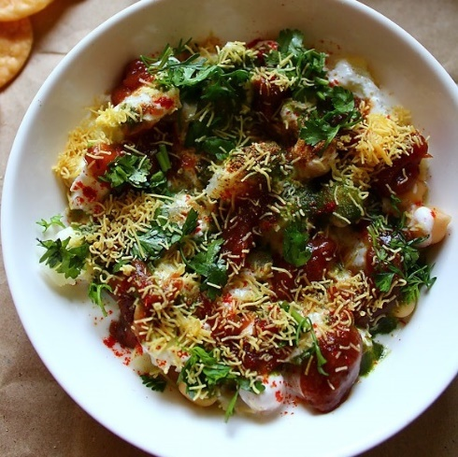
- Khasta kachori chaat: 2 pcs (V)-7.99
Stuffed pastry with lightly spiced moong dal stuffing and topped with onion, tomato, sev, yogurt and chutneys.
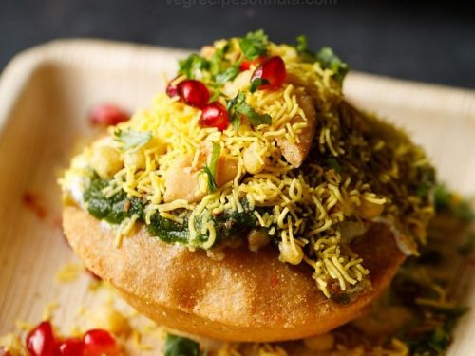
Non-vegetarian appetizers
- Lamb keema samosa: 2pcs (GF)-8.99
Golden crisp tringle filled with mildly spiced minced lamb.
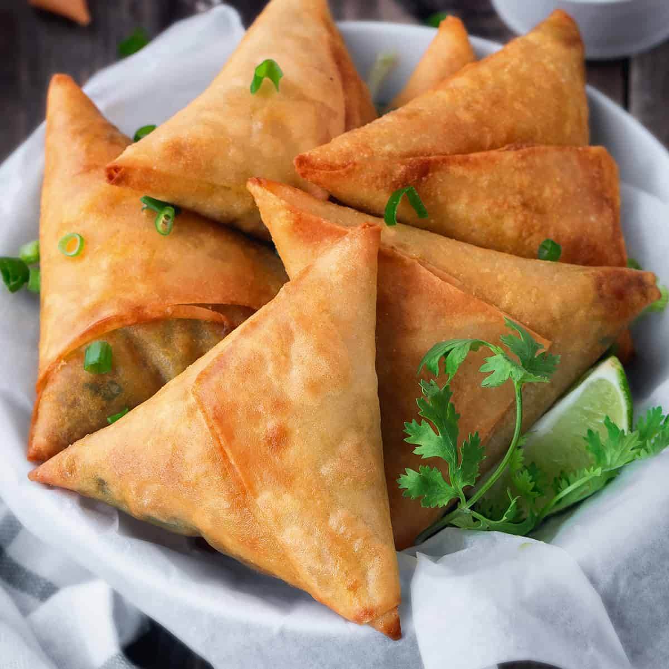
- Fish fried Amritsari (GF)-9.99
Seasonal fish marinated and fried in Amritsari style. A speciality of the Punjab region.
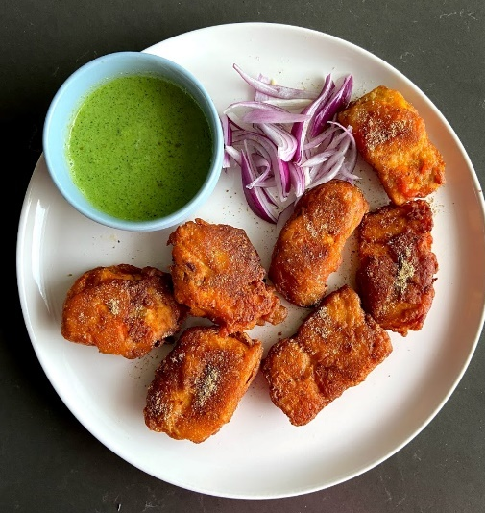
- Chicken pakora (GF)-9.99
Boneless chicken fritters mildly spiced.
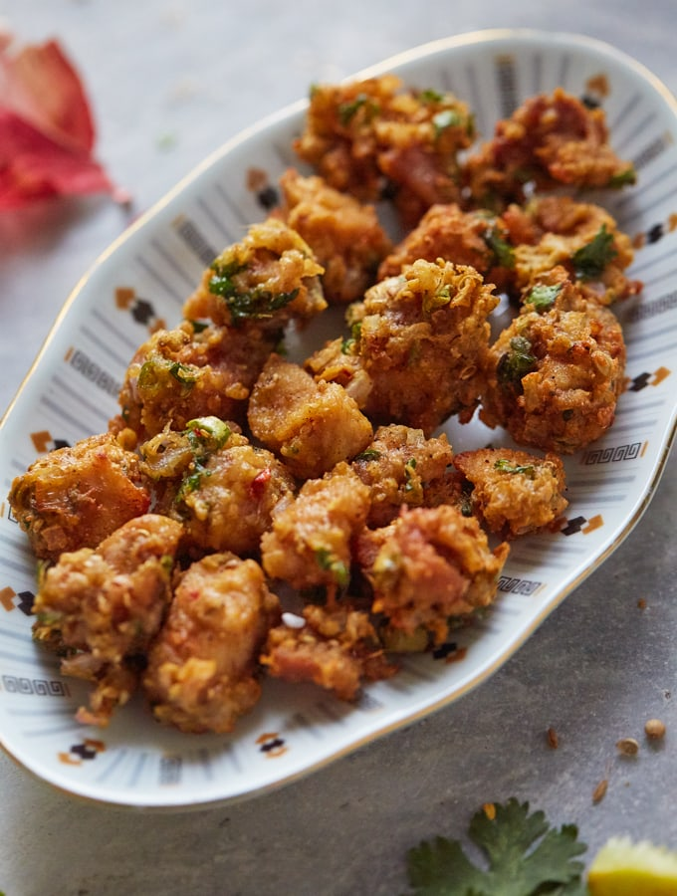
- Coconut shrimp (GF)-9.99
Shrimp coated and deep fried
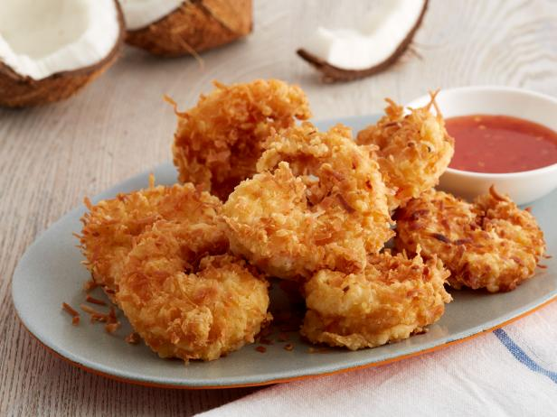
- Chicken 65 (GF)-9.99
Boneless chicken cooked in south-Indian style. It was named chicken 65 because originally 65 chillies were used per kilogram of chicken to prepare it.
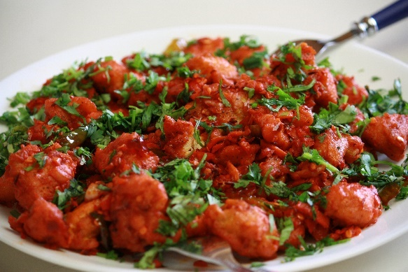
- Assorted non-veg. platter-11.99
Keema samosa,chicken pakora, fish fried, coconut shrimp.

Street corner
- Vada-pav(V)-8.99
Deep fried potato dumpling placed inside a bread bun and topped with condiments.
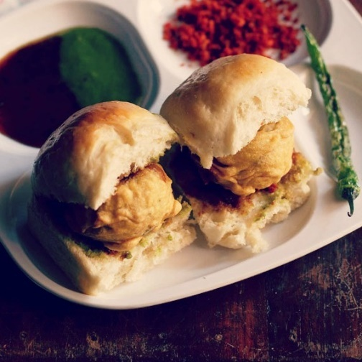
- Channa bhatura(V)-10.99
2 Puffed deep fried Indian bread served with chickpea curry.
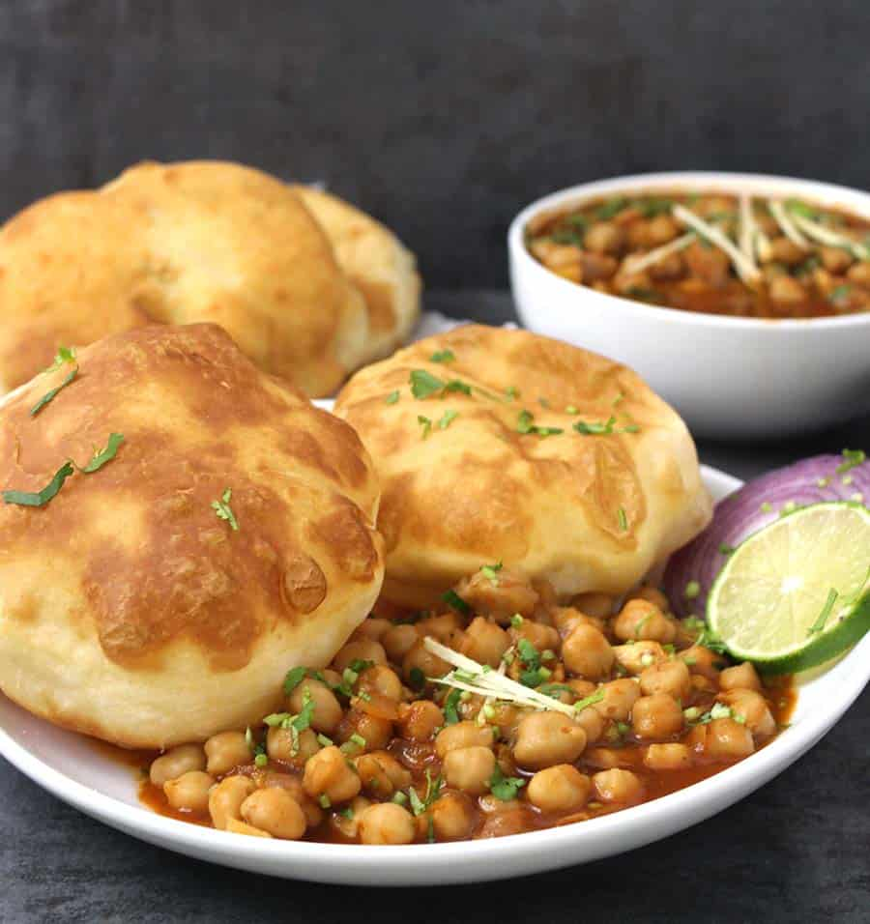
- Poori aloo(V)-10.99
2 puffed deep-fried whole-wheat bread served with potato curry.
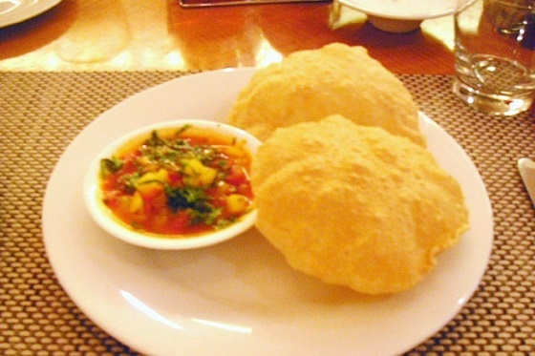
- Pao bhaaji-10.99
Thick vegetable curry of minced vegetables served with a soft bread roll.
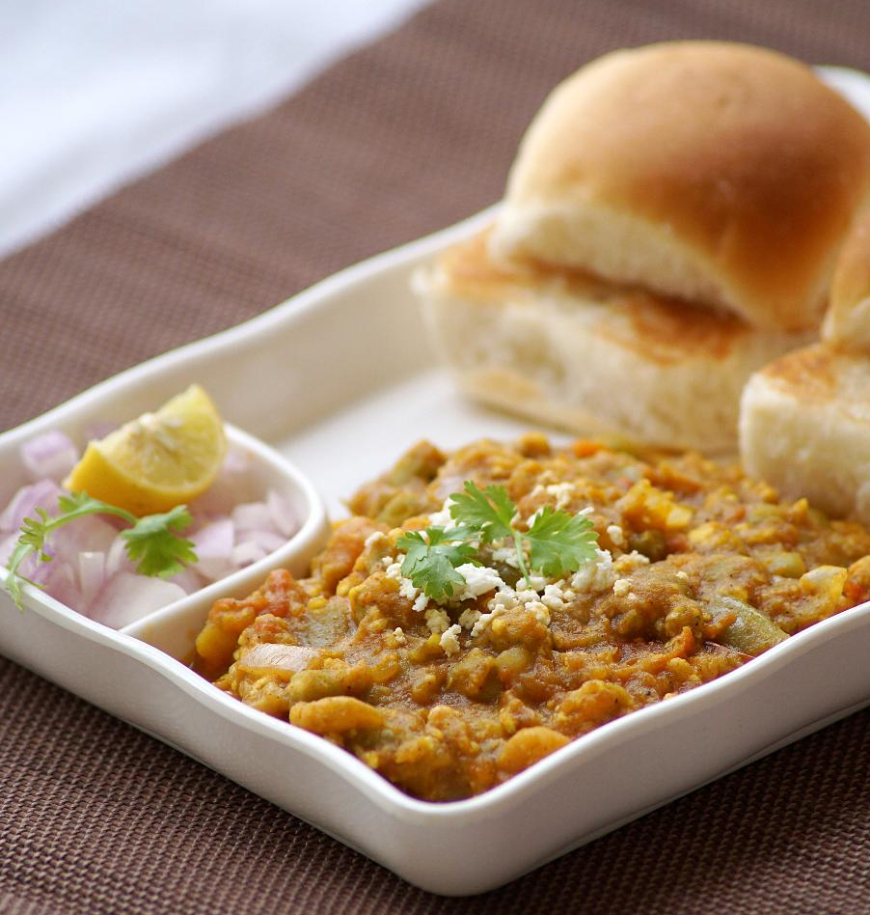
Soups and salads
- Mulligatawny Chicken soup (GF)-6.99
Stew of chicken and vegetables
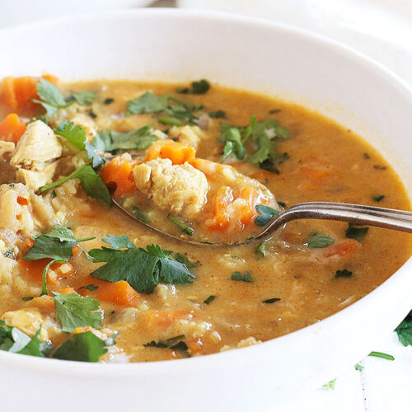
- Mulligatawny Vegetable Soup (V GF)-4.99
Vegetable and lentil soup
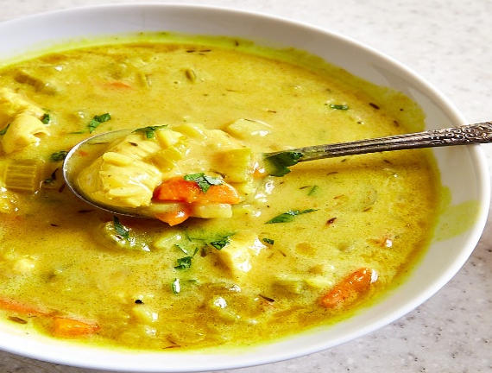

- Tomato soup (V GF)-4.99
Stew of tomatoes
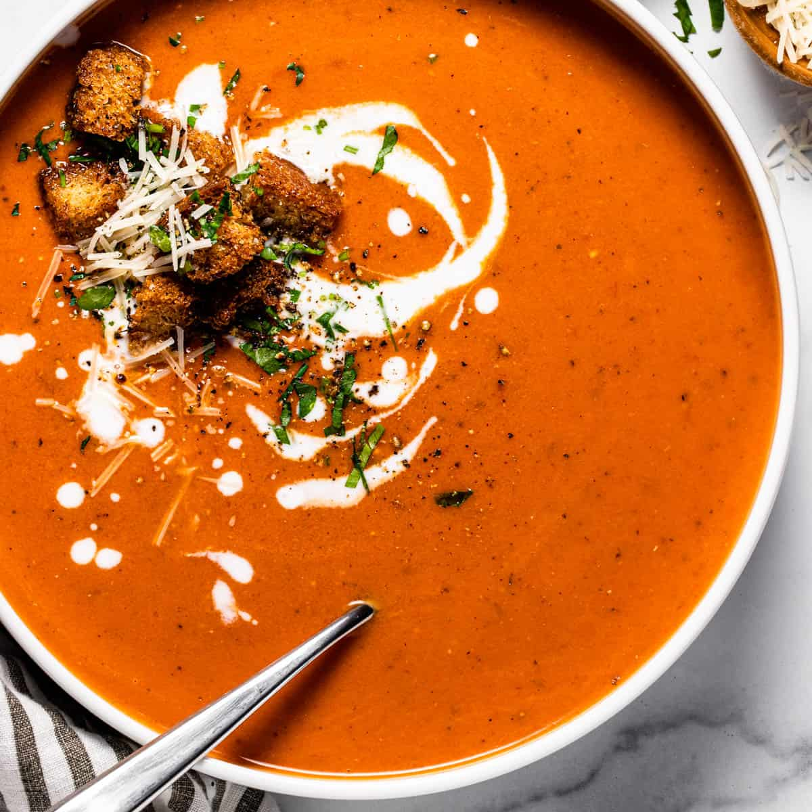
- Sambhar (V GF)-4.99
Lentil based vegetable stew
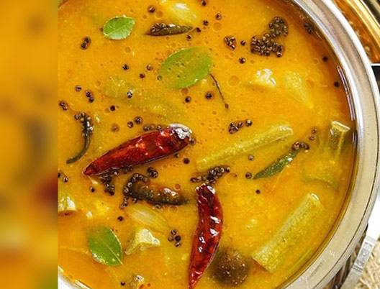
- Rasam (V GF)-4.99
Light South Indian soup made with tomatoes, tamarind and herbs.
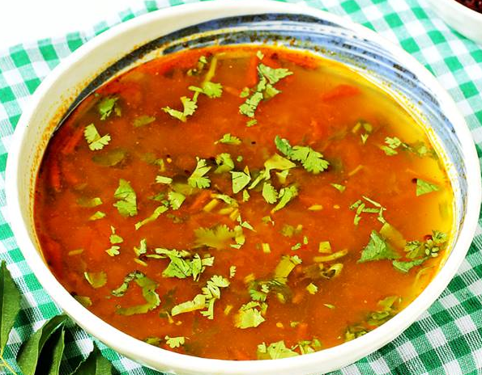
- Garden salad (V GF)-5.99
Lettuce, tomatoes, cucumbers, carrots and onions.
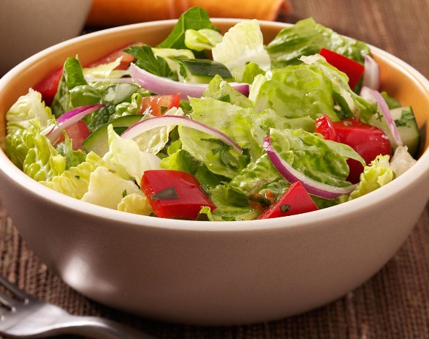
- Quinoa salad (V)-7.99
Quinoa, tomatoes, cucumbers, red onions
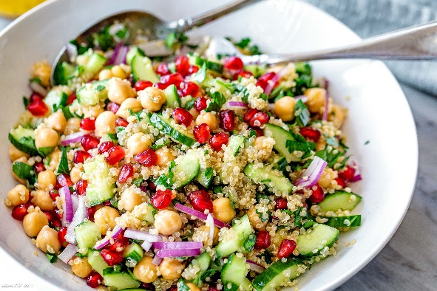

Kathi rolls
(Kathi roll is a chappati bread rolled with vegetables/paneer/egg/chicken or lamb topped with lettuce, tomatoes, onion and condiments)
- Vegetable kathi roll-9.99 ML MD H
Chapati bread roll filled with assorted vegetables
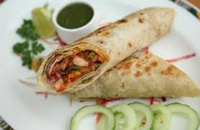
- Paneer kathi roll-11.99 ML MD H
Chapati bread roll filled with cubes of home-made cheese and lettuce, tomatoes, onion and condiments
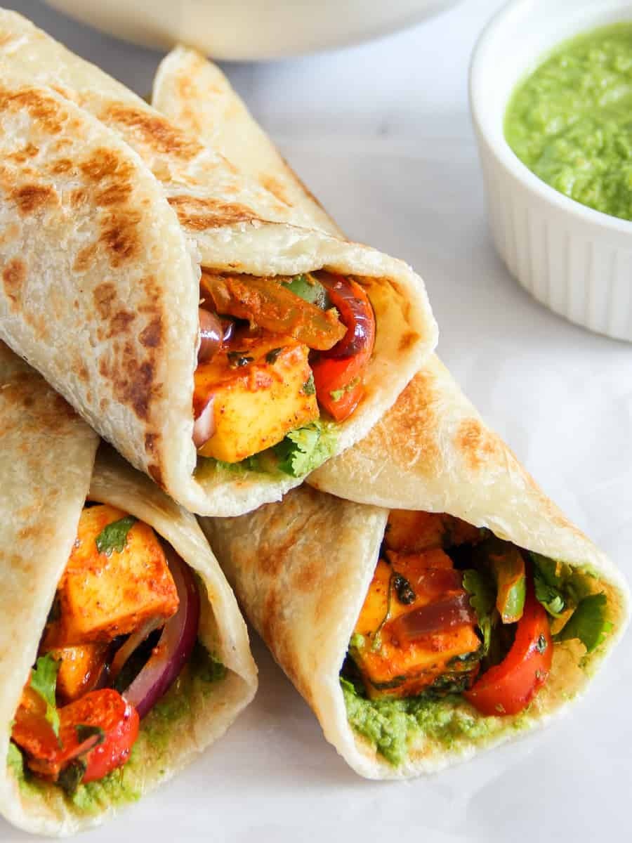
- Egg kathi roll-11.99 ML MD H
Chapati bread roll filled with scrambled eggs and vegetables
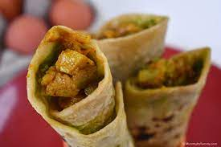
- Chicken kathi roll-13.99 ML MD H
Chapati bread roll filled with cubes of chicken and vegetables
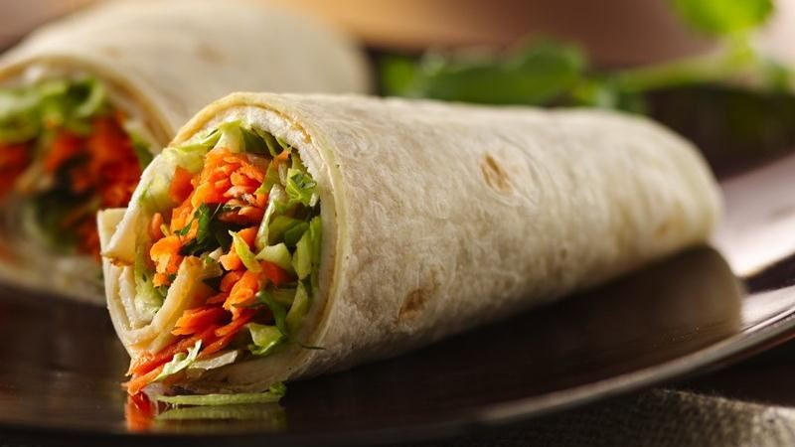
- Lamb kathi roll-14.99 ML MD H
Chapati bread roll filled with chunks of tandoori lamb and vegetables
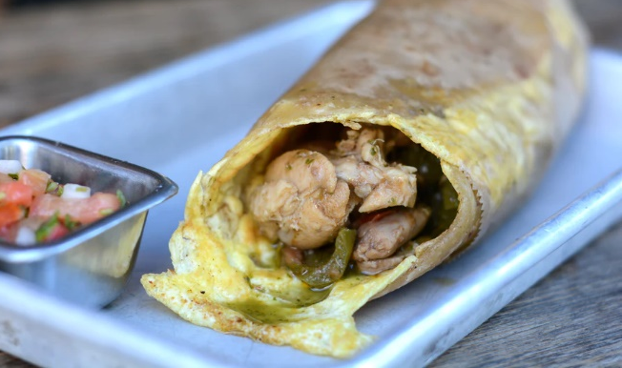

Tandoori delicacies

- Chicken tandoori- 12.99 (GF) ML MD H
Bone-in chicken marinated in yogurt and mild spices then cooked in a clay oven- a specialty of the punjab region of india.
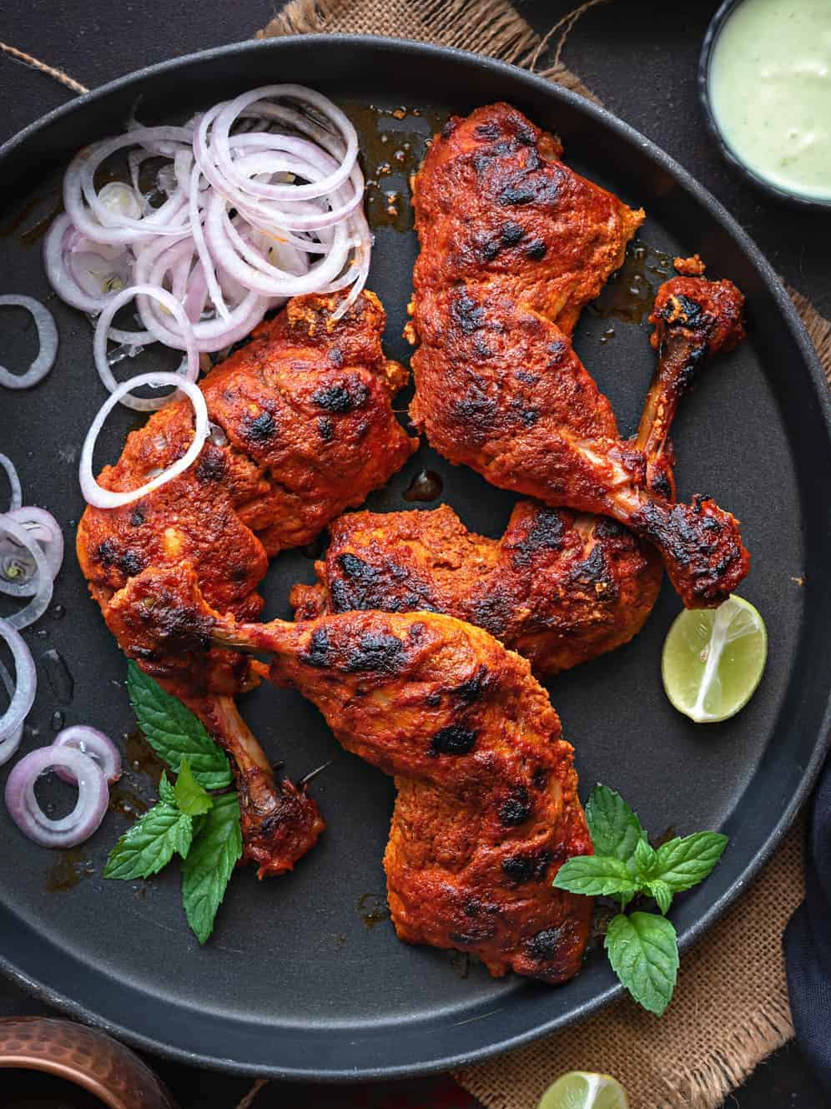
- Chicken malai or Reshmi kebab-12.99 (GF) ML MD H
Soft and tender chunks of chicken breast marinated in a special marinade and grilled
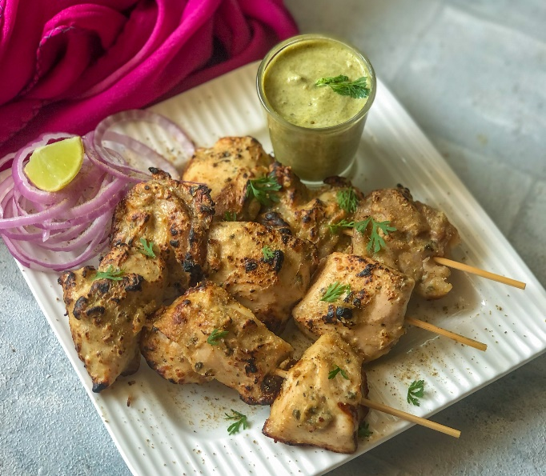
- Ginger chicken kabab-12.99 (GF) ML MD H
Soft and tender pieces of chicken breast marinated in ginger marinade and grilled
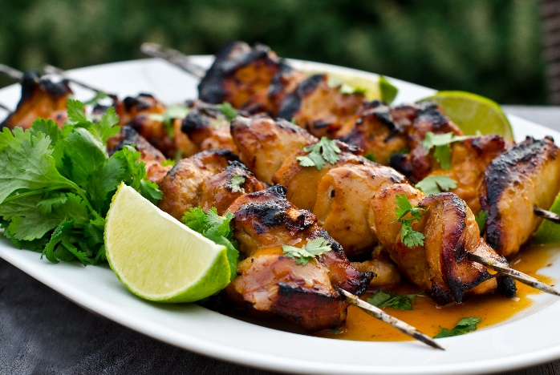
- Chicken seekh kabab-12.99 (GF) ML MD H
Minced chicken mixed with onions, choice of herbs and spices, then skewered and grilled in the tandoor.
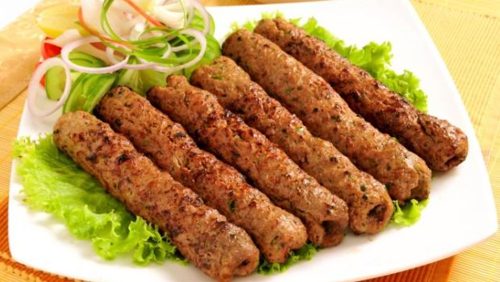
- Hariyali chicken tikka kebab-12.99 (GF) ML MD H
Boneless chicken breast marinated in yogurt mixed with green herbs and then roasted in the clay oven.
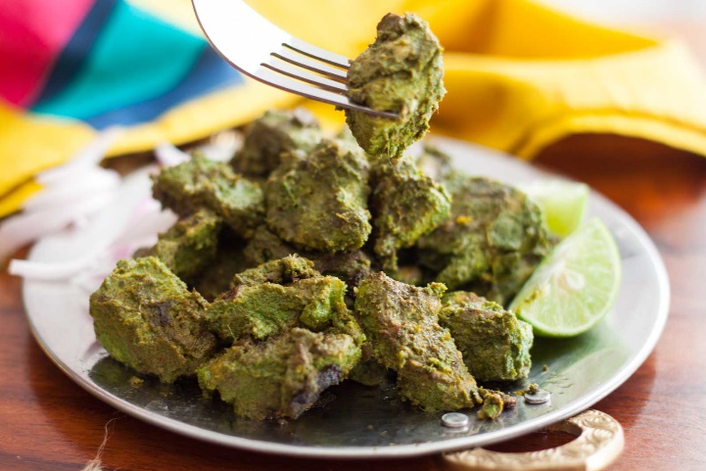
- Tandoori fish tikka-17.99 (GF) ML MD H
Tender boneless prices of salmon or tilapia marinated and broiled in the tandoor.
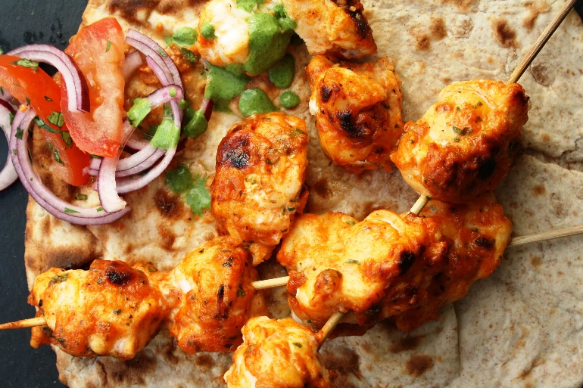
- Tandoori jumbo shrimp-17.99 (GF) ML MD H
Jumbo shrimp marinated and grilled in tandoor and served on skewers with onions and bell peppers.
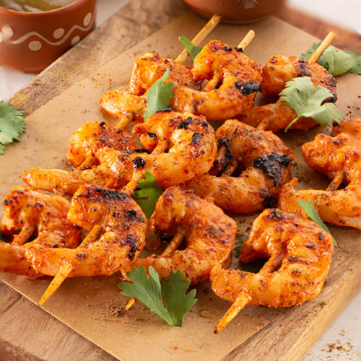
- Lamb boti kabab-17.99 (GF) ML MD H
Boneless pieces of tender lamb marinated in special spices and barbecued in the tandoor.
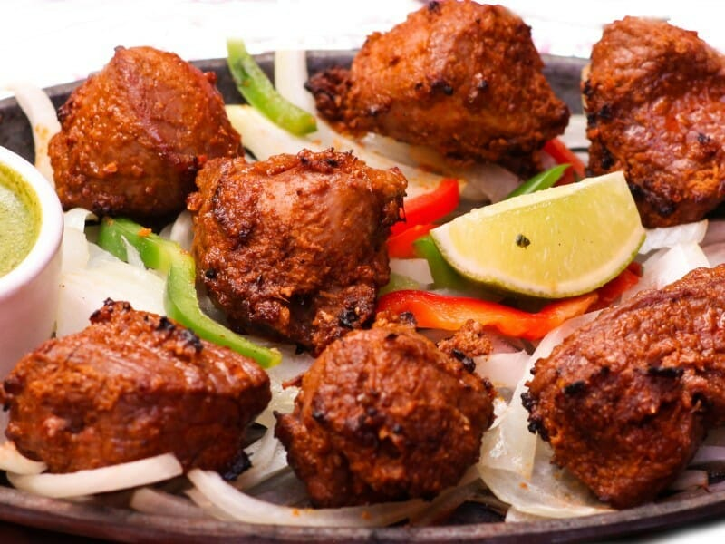
- Lamb chops-17.99 (GF) ML MD H
Lamb chops marinated overnight and roasted in a clay oven.
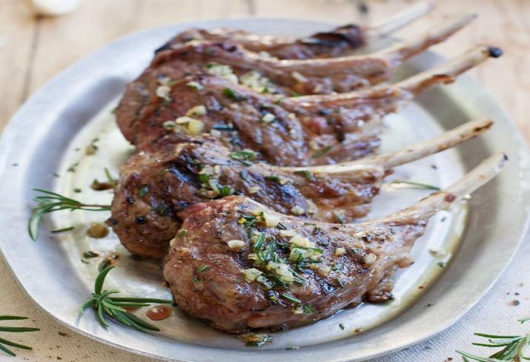
- Lamb seekh kebab-14.99 (GF) ML MD H
Mined lamb mixed with onion, choice herbs and spices, then skewered and grilled in the tandoor.
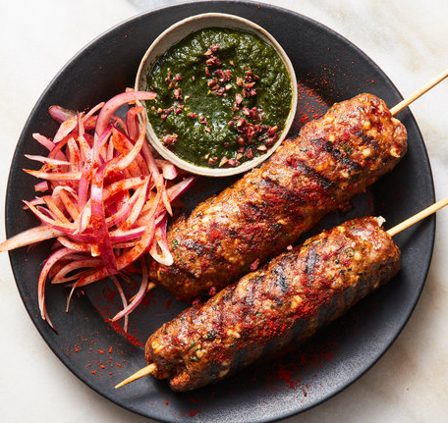
- Paneer tikka tandoori-14.99 (GF) ML MD H
Cubes of home-made cheese marinated in special herbs and spices then cooked in tandoor.
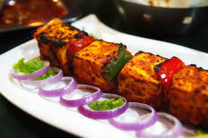
- Vegetable sizzler-14.99 (GF) ML MD H
Marinated fresh vegetables skewered on low heat in the tandoor.
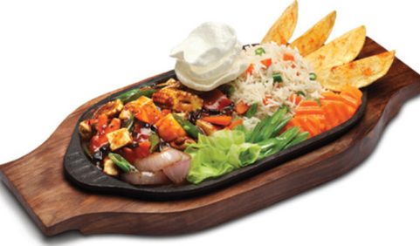
- Taj special-17.99 (GF) ML MD H
Combination of tandoori chicken,chicken tikka, lamb chop, seekh kabab and jumbo shrimp.

Main course:
Vegetarian

- Yellow Tadka daal (V GF)-10.99 ML MD H
Yellow lentil of the day cooked with rare herbs and spices
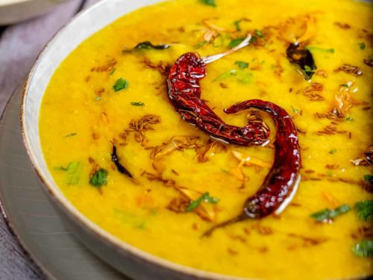
- Methi malai matar (GF)-11.99 ML MD H
Fenugreek and peas cooked in gourmet sauce.
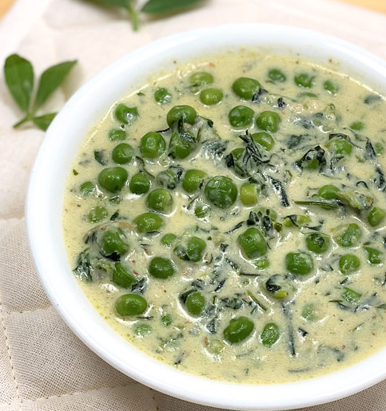
- Bhindi masala (V GF)-11.99 ML MD H
Delicious cut okra stir fried with onion in a kadhai.
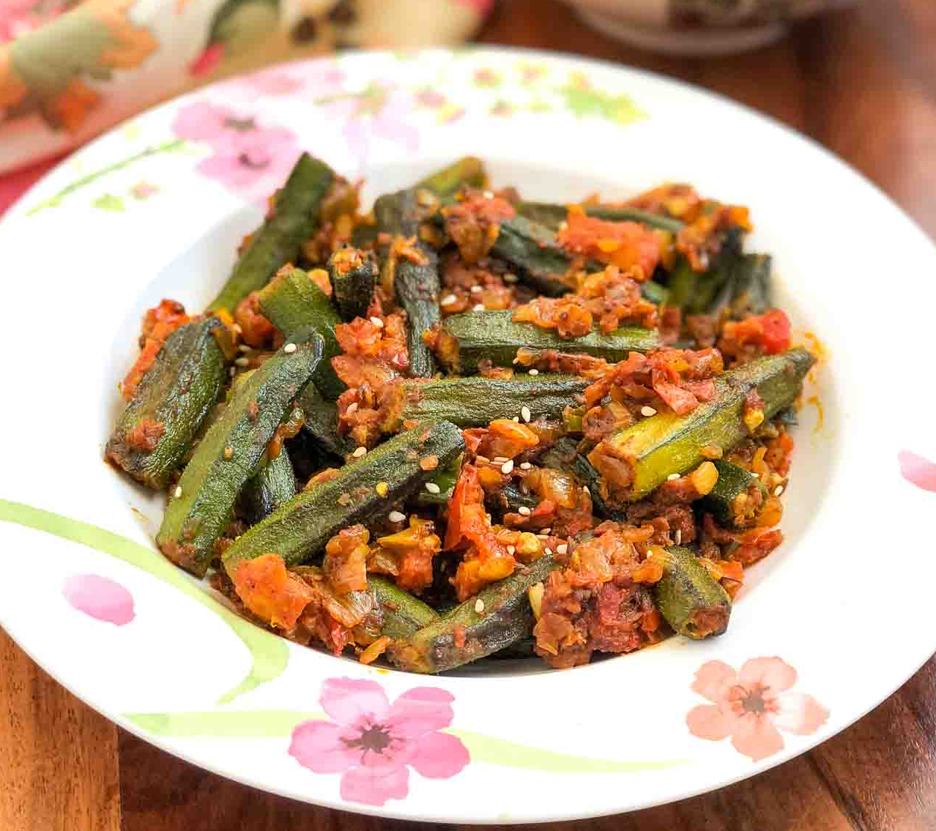
- Malai kofta (GF)-11.99 ML MD H
Home-made cheese and fresh vegetable balls cooked in a gourmet sauce.
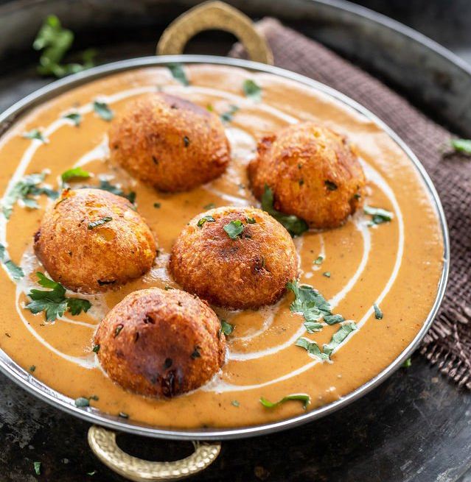
- Paneer tikka masala (GF)-12.99 ML MD H
Home-made cheese cubes roasted and cooked in a creamy tomato sauce.
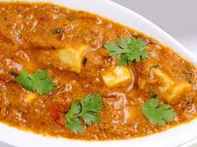
- Paneer Butter Masala (GF)-12.99 ML MD H
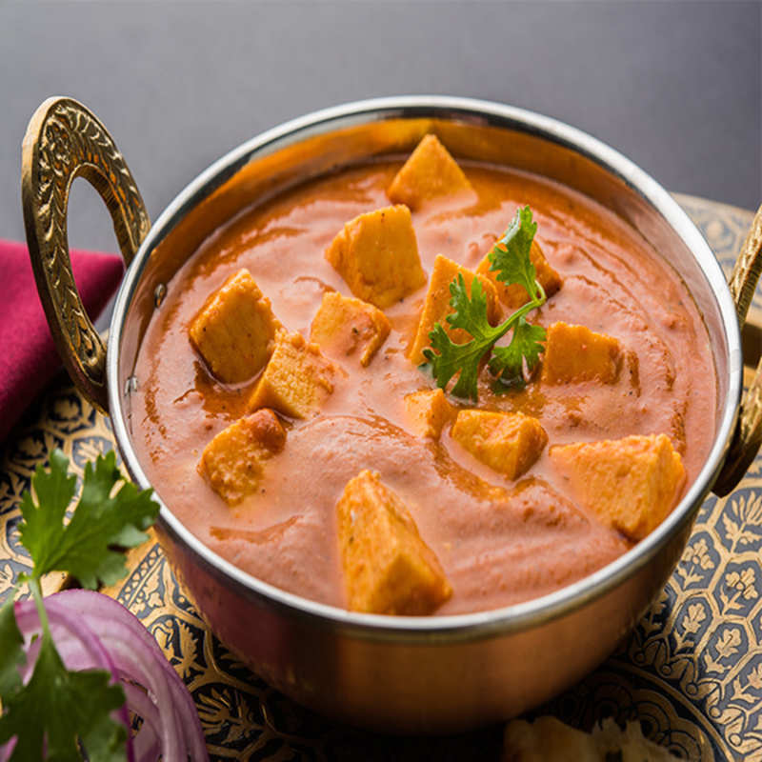
- Daal makhini (GF)-11.99 ML MD H
A combination of whole black beans and red kidney beans simmered overnight and lightly fried in butter.
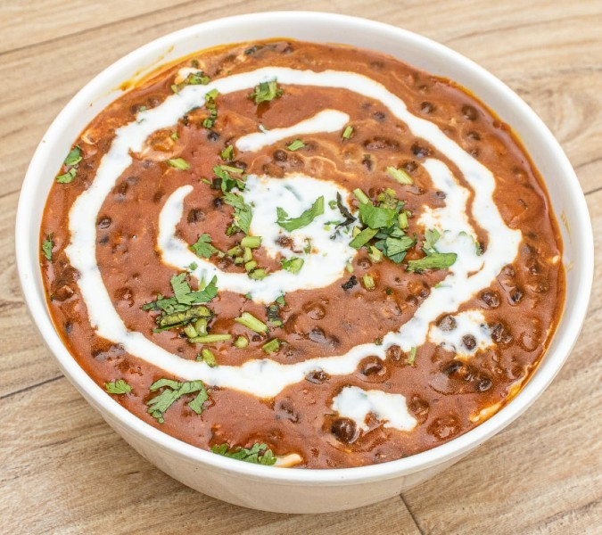
- Rajma (V GF)-11.99 ML MD H
Kidney beans cooked in a tomato sauce.
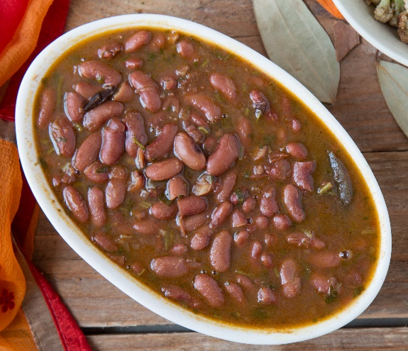
- Paneer shahi korma (GF) -12.99 ML MD H
Freshed cottage cheese cooked in a cashew and almond sauce.
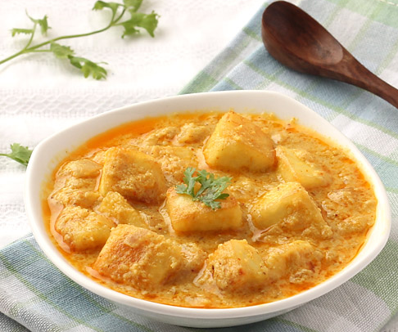
- Paneer bhurji (GF)-12.99 ML MD H
Fresh home-made cheese grated and cooked with green peas and onion.
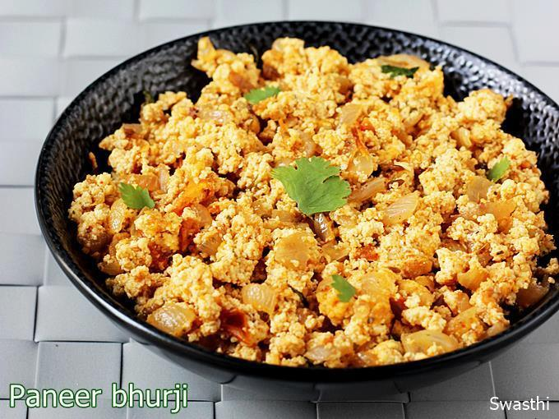
- Kadhai paneer (GF) 12.99 ML MD H
Fresh home-made cheese cubes stir-fried with onions,ginger and bell peppers.
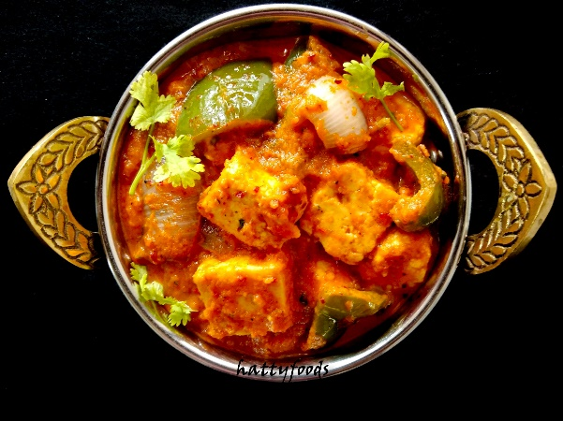
- Mattar paneer (GF)-12.99 ML MD H
Fresh peas and cheese cooked in tomato sauce.
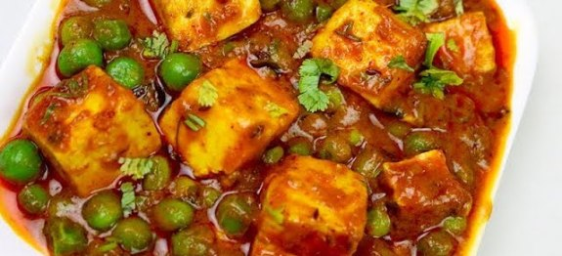
- Matar aloo- (V GF )11.99 ML MD H
Fresh peas and potatoes cooked in a tomato sauce.
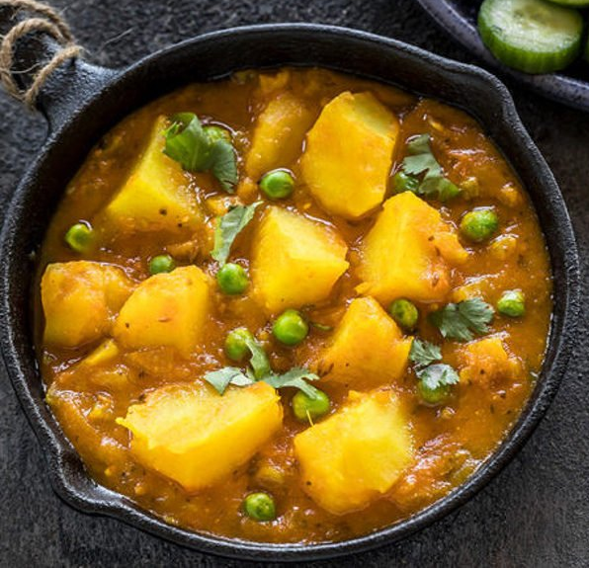
- Matar mushroom (V GF)-11.99 ML MD H
Fresh peas and mushrooms cooked in tomato sauce.
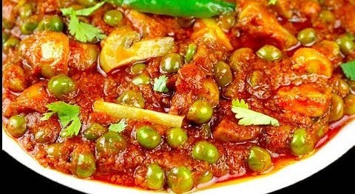
- Vegetable vindaloo (V GF)-11.99 ML MD H
Fresh vegetables and potatoes cooked with herbs and spices.
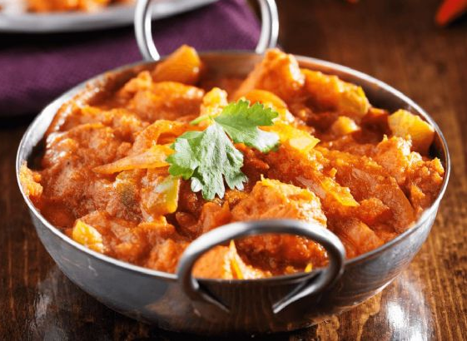
- Vegetable jalfrezi (V GF)-11.99 ML MD H
Fresh assorted vegetables cooked in tomato sauce.
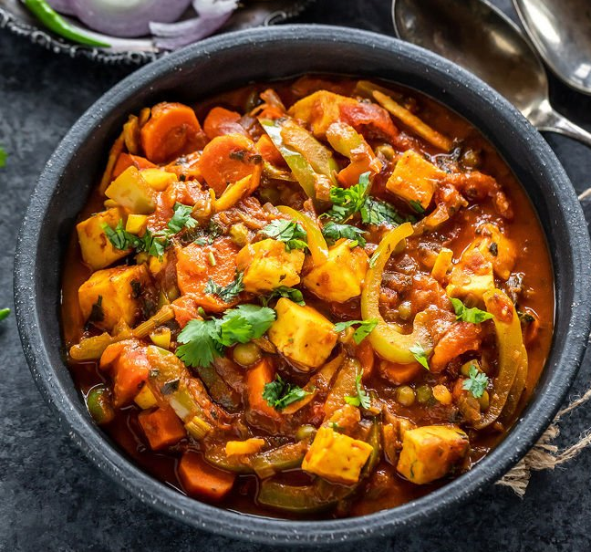
- Aloo mirch (V GF)-11.99
Potatoes with bell pepper.
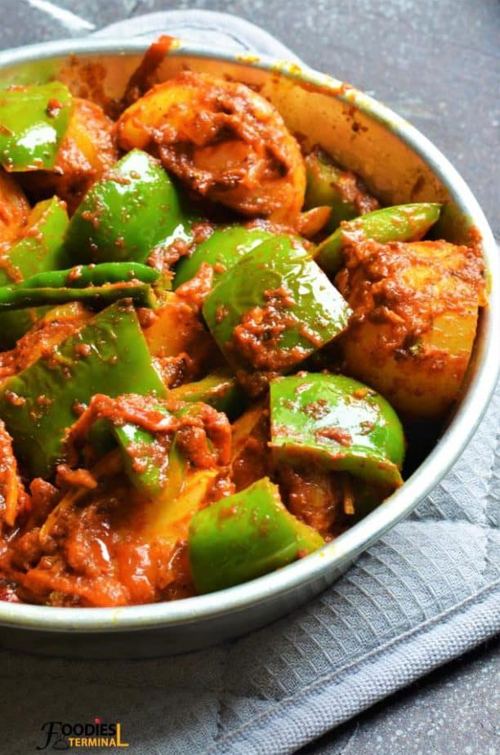
- Kashmiri dum aloo (GF)-11.99 ML MD H
Whole potatoes cooked in Kashmiri sauce.
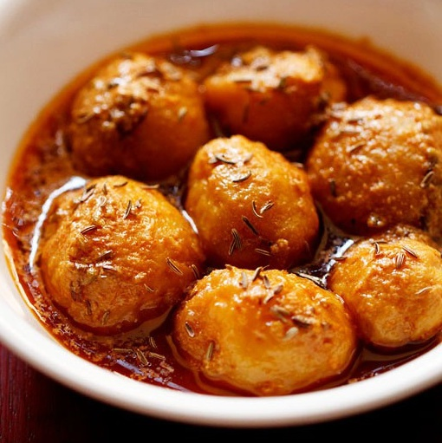
- Aloo abkari (GF) -11.99 ML MD H
Potatoes filled with cheese, nuts and herb then cooked in a special gourmet sauce.
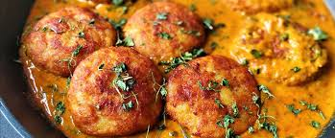
- Methi aloo(V GF)-11.99 ML MD H
Fenugreek and potatoes cooked with special herbs and spicies.
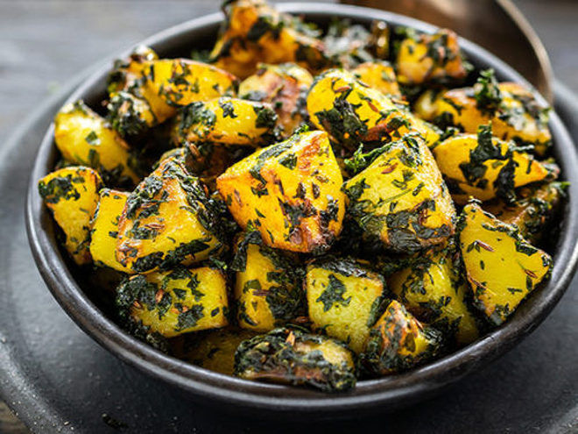
- Mirchi salan(V GF) -11.99 ML MD H
Banana pepper filled with potatoes, herbs, spices and then stir fried.
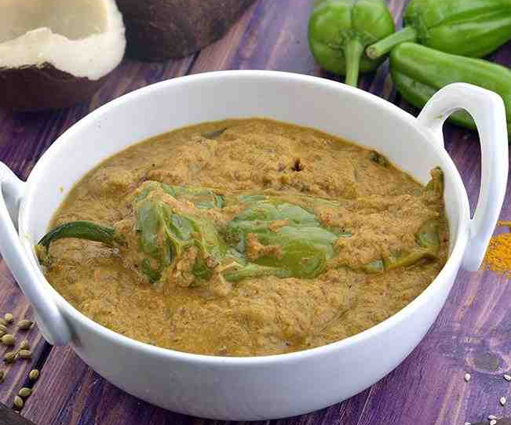
- Aloo gobhi(V GF)-11.99 ML MD H
Fresh cauliflower and potatoes stir fried with mild spices.
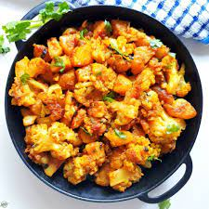
- Aloo achari(V GF)-11.99 ML MD H
Potatoes with pickled spices.
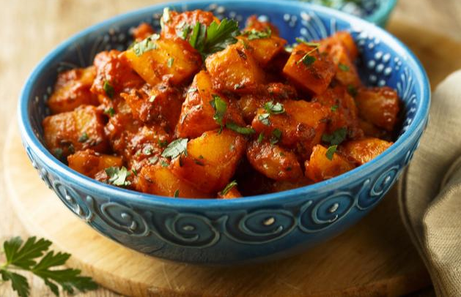
- Gobhi kaju(V GF)-11.99 ML MD H
Fresh cauliflower and cashew cooked with exotic spices.
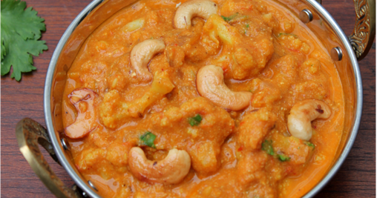
- Vegetable navrattan shahi korma(GF)-11.99 MLMD H
Nine mixed vegetables cooked in a cashew and almond sauce.
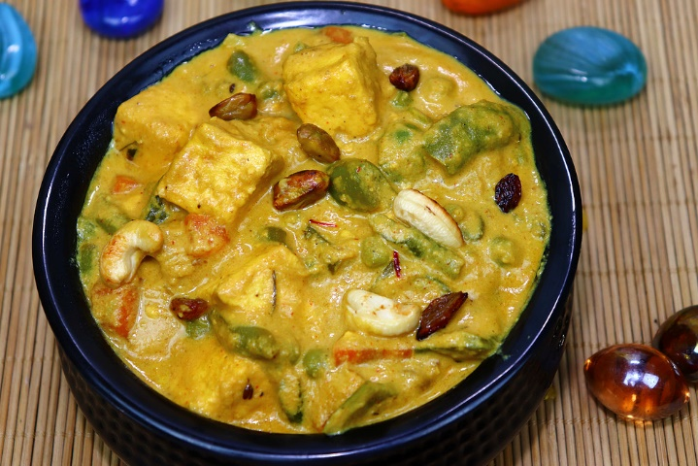

- Baingan aloo(V GF) -11.99 ML MD H
Fresh cubes of eggplant cooked with potatoes,tomatoes and flavored with ginger.
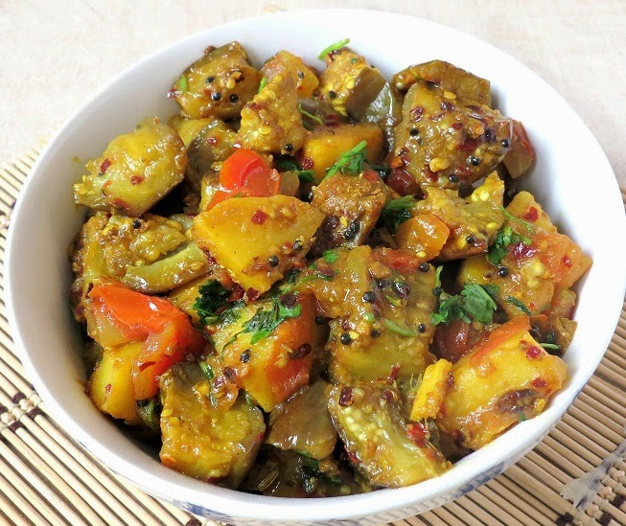
- Baingan bhartha(V GF) -11.99 ML MD H
Eggplant roasted on charcoal, minced and cooked with ginger,onion and tomatoes.
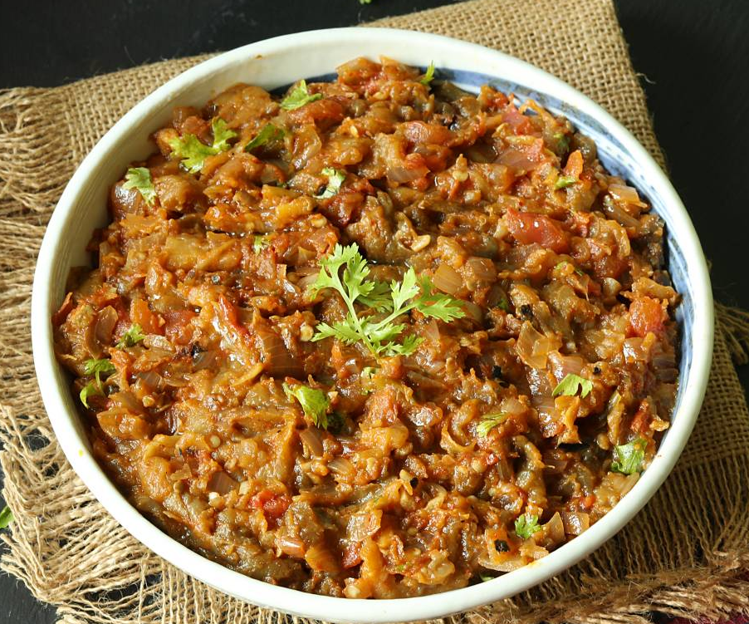
- Bhagare baingan(V GF) -11.99 ML MD H
Baby eggplant stuffed with herbs and spices and then stir fried.
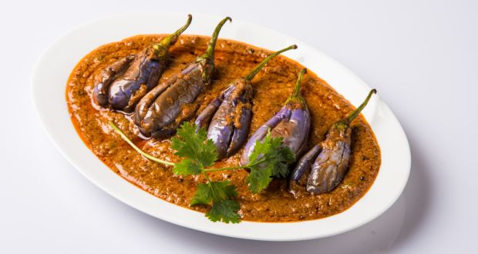
- Channa masala(V GF) -10.99 ML MD H
Delicious chickpeas cooked in exotic blend of north Indian spices.
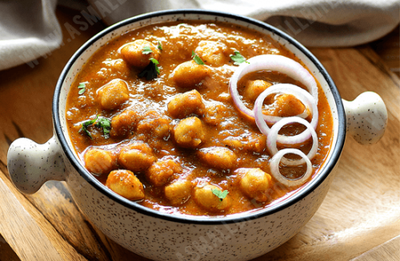
- Kadhi pakora -11.99 ML MD H
Chickpea and lentil balls cooked in a yogurt sauce.
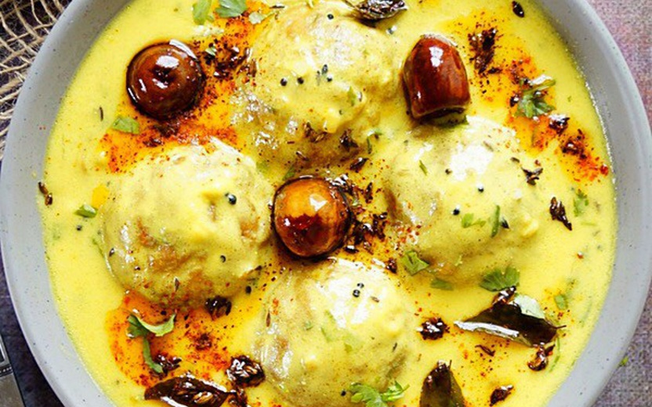
- Palak kale(V GF) -11.99 ML MD H
Fresh spinach and kale cooked with herbs and spices.
- Kadhai saag(V GF) – 11.99 ML MD H
Mustard green and spinach
- Tofu, Broccoli and Mushroom(V GF) – 11.99 ML MD H

Curries
- Korma: Almond and cashew sauce, served with your choice of protein. Pick one. All these dishes are GF.
Chicken korma.-12.99 ML MD H
Lamb korma.-14.99 ML MD H
Fish korma-14.99 ML MD H
Shrimp korma.-15.99 ML MD H
Goat korma – 14.99 ML MD H

- Chettinad : Spicy gravy with coconut milk and peppers, cooked with your choice of proteins. Pick one, All these dishes are GF.
Chicken chettinad -12.99 ML MD H
Lamb chettinad -14.99 ML MD H
Fish chettinad -14.99 ML MD H
Shrimp chettinad-15.99 ML MD H
Goat chettinad – 14.99 ML MD H

- Tikka masala: Light and creamy tomato sauce, cooked with your choice of protein. Pick your choice from the following: All these dishes are GF.
Chicken tikka masala-12.99 ML MD H
Lamb tikka masala-14.99
Fish tikka masala-14.99
Shrimp tikka masala-15.99
Goat Tikka Masala- 14.99

- Saagwala: Fresh spinach cooked with your choice of protein. Pick your choice from the following: All these are GF.
Chicken saagwala-12.99 ML MD H
Goat saagwala-14.99
Fish saag wala-14.99
Shrimp saag wala-15.99
Lamb saag wala-14.99

- Curry: Choices of protein cooked in a tomatoes, ginger, garlic, herbs and spices. Pick one from the following choices: All these dishes are GF.
Chicken curry -12.99 ML MD H
Lamb curry -14.99
Goat curry -14.99
Fish curry -14.99
Shrimp curry -15.99

- Vindaloo: Potatoes cooked in a super-hot tangy sauce with your choices of protein. Following are the options: All these dishes are GF.
Chicken vindaloo -12.99 ML MD H
Fish vindaloo -14.99
Goat vindaloo -14.99
Lamb vindaloo -14.99
Shrimp vindaloo -15.99
- Rogan josh: A Kashmiri region specialty made with yogurt and aromatic blend of spices. Pick one of your choice: All these dishes are GF,
Chicken rogan josh -12.99 ML MD H
Goat rogan josh -14.99
Lamb rogan josh -14.99
Fish rogan josh- 14.99
Shrimp rogan josh -15.99

- Kadhai: Curry stir fried with onions and bell pepper, and your choice of protein. Indicate your choice from the following: All these dishes are GF,
Chicken kadhai -12.99 ML MD H
Lamb kadhai -14.99
Goat kadhai -14.99
Fish kadhai -14.99
Shrimp kadhai -15.99

- Bhuna: Tender pieces of meat cooked in rich spices. Pick your choice: All theses are GF
Chicken Bhuna -12.99 ML MD H
Goat bhuna -14.99
Lamb bhuna -14.99
Fish bhuna – 14,99
Shrimp bhuna – 15.99

- Makhini: Rich tomato butter sauce cooked with choice of protein. Following are the options: All these dishes are GF.
Chicken makhini -12.99 ML MD H
Goat makhini -14.99
Lamb makhini -14.99
Fish makhini -14.99
Shrimp makhini -15.99

- Mango curry: Ground mango in an onion and tomato gravy cooked with your choice of proteins. Options: All these dishes are GF.
Chicken mango curry -12.99 ML MD H
Goat mango curry -14.99
Shrimp mango curry -15.99
Lamb mango curry -14.99
Fish mango curry -14.99

- Keema matar: minced mutton cooked with whole spices and with your choice of protein. Choices: All these dishes are GF.
Chicken keema matar – 12.99 ML MD H
Lamb keema matar-14.99

Breads
- The breads made with All purpose flour or Whole wheat flour. A naan is a flat leaved bread with all purpose flour. A kulcha is a naan bread stuffed with some vegetable or meat. A paratha is made with wheat flour. It can be plain or stuffed. The following options are available, Please pick one:
Indicate All purpose flour or Wheat flour
- All purpose flour Wheat flour

- Butter Naan (only all purpose flour)
- Onion
- Garlic
- Potatoes
- Paneer (home made cheese)
- Cauliflower
- Mushroom
- Spinach
- Mint
- Kashmiri (sweet stuffed with cherries)
- Kabuli Stuffed with Nigella and sesame
- Chicken
- Lamb
- Gluten free Naan
- Bhatura-2.99 (2 pieces)(all purpose flour)
(Leavened and fermented naan bread deep fried)
- Lachha Paratha-2.99 (plain whole wheat bread)
- Poori – 2.99 (2 pieces) (only wheat flour)
(Whole wheat puffed deep fried bread)
- Tandoori roti-2.99 ( wheat flour)
(Traditional whole wheat bread baked in our clay oven.)
- Chappati-2.99 (2 pieces) ( wheat flour)
(Whole wheat thin bread baked on a skillet)
- Missi roti-3.99 ( wheat flour)
(a multi-grained mildly spiced bread
- Lachha paratha-2.99 ( wheat flour)
- Bread basket-7.99
(combination of butter naan, garlic naan and aloo paratha (no substitutes)
Rice specialities:
Dum Biryani: In Dum Biryani the ingredients are slowly cooked in a sealed container so that the ingredients are cooked in their own juices, mostly any meat cooked with rice. Nuts, raisins and saffron are added which is optional.
- Vegetable dum biryani-10.99 ML MD H
- Chicken dum biryani-12.99
- Lamb dum biryani-14.99
- Beef dum biryani-14.99
- Goat dum biryani-14.99
- Shrimp dum biryani-15.99
- Taj special biryani-15.99
- Egg Biryani-12.99
- Paneer Biryani-12.99
- Jeera rice-2.99
- Lemon rice-7.99
- Peas rice-7.99
- Tamarind Rice - 799
- Tomato Rice - 7.99
- Yogurt Rice – 7.99
- Cocunut Rice – 7.99

Indo-chinese
Indo Chinese is the adaption of Chinese cooking using Indian and chinese ingredients. Please pick one from the following:
Fried Rice Dishes:
- Vegetable(GF V)-10.99 ML MD H
- Chicken(GF)-12.99
- Lamb(GF)-13.99
- Shrimp(GF)-.15.99
- Egg(GF)-11.99
Noodle Dishes:
- Vegetable(GF)-10.99
- Chicken(GF)-12.99
- Lamb(GF)-13.99
- Shrimp(GF)-15.99
Manchurian Dishes:
- Gobhi(V) (Cauliflower)-11.99
- Broccoli(V) – 11.99
- Paneer – 12.99
- chicken-12.99
- Lamb – 14.99
- Shrimp – 15.99
- Tofu
Chilli Dishes
- Paneer-12.99
- chicken-12.99
- shrimp-15.99
- Lamb – 13.99
- Tofu – 12.99

South Indian corner
- Dosa: Dosa is a crispy rice and lentil crepe. The following options are available. Please pick one
Plain: - 8.99
Masala: -9.99
filled with potatoes, onions and herbs,
Spring: -10,99
filled with assorted vegetables
Paneer:- 12.99
Filled with home-made scrambled cheese, onion and herbs.
Mysore Plain (10.99)
- Dosa with spicy chutney.-12.99
Mysore masala(12.99)
Dosa filled with vegetables and spicy chutney. -12.99
- Medhu vada:2 pcs (V GF)-7.99
Donut shaped lentil cakes served with sambhar and coconut chutney
- Idly sambhar (V GF)-7.99
Steamed rice and lentil cakes served with sambhar and coconut chutney.
- Idli Manchurian (V GF)-7.99
Steamed rice and lentil cakes cooked in a sweet and sour sauce mixed with Indian herbs.
- Uttapam (V GF)-7.99
Thick pancake made with dosa batter. Flavors are:
- Onion
- Tomato
- Green chillies

Kids menu
- Chicken tenders and French fries.-8.99
- Fish fillet and French fries.-8.99
- French fries.-4.99

Accompaniments
- Papadam-3.50
(Mildly spiced flat lentil wafers.)
- Garden raita-5.99
(Cool home-made yogurt mixed with cucumbers, tomatoes and herbs)
- Plain yogurt-4.99
(Cool home-made yogurt)
- Achaar-3.99
(Hot and very spicy mixed vegetable pickle)
- Mango chutney-3.99
(Sweet and mildly spiced mango sauce)
- Mint chutney-3.99
(Made with fresh mint leaves, green chillies, fresh coriander, salt and fresh lemon juice)
- Tamarind chutney-3.99
(Tamarind mixed with brown sugar and Indian herbs)
- Onion chutney-3.99
(Onions mixed with tomatoes and spices)
- Coconut chutney-3.99
(Coconut crushed and blended with Indian spices and herbs)

Deserts
- Kheer-4.99 (GF)
(Rice pudding flavored with cardamom, nuts and raisins)
- Gulab jamun:2 pieces-5.99
(Golden fried balls of milk pastry soaked in honey and saffron syrup)
- Rasmalai:2 pieces-6.99 (GF)
(Chilled cheese dumplings served in milk syrup, topped with pistachios)
- Gajar halwa-6.99 (GF)
(Freshly grated carrots cooked with milk, cottage cheese and nuts)
- Sooji Halwa-4.99 (cream of wheat pudding)
- Moong Dal Halwa-6.99 (GF) (Lentil pudding)
- Mango Ice Cream – 4.99
- Kesar Pista Ice Cream – 4.99
- Pan IceCream – 4.99
- Lichi Ice Cream – 5.99
- Ckikoo Ice Cream – 5.99
- Vanila Ice Cream – 4.99
- Chocolate Ice Cream – 4.99
- Kesar Pista Kulfi -4.99
- Malai Kulfi 4.99
- Mango Ice Cream – 4.99

- FRESHLY MADE SWEETS 10.99/lb

Drinks
- Mango lassi-2.99
(A refreshing yogurt mango drink)
- Tea -1.99
(Indian aromatic tea made with the highest grade of tea leaves brewed with cardamom, cloves, cinnamon,with/without sugar and milk)
- Decaffenited Tea – 1.99
- Green Tea – 1.99
- Madras Coffee – 2.99
- Regular Coffee – 1.99
- Decaffenited Cofee – 1.99
- Cold coffee – 3.99
- Soda-1.99
- Water bottle-1.50

